Journal Primary Article, Review, and Research Protocol Template


Title Page

Full Title of Article:
Exploring the Feasibility of Applying Deep Learning for the Early Prediction of Arthritis

Full Names, Academic Degrees, Institutional Affiliations, and Email Addresses for All Authors
Jiaxuan Chen, HBSc Student [1], Xiangxuan Kong, HBSc Student [2]
[1] Faculty of Arts and Science, University of Toronto, Toronto, Ontario, Canada, M5S 1A1, dcjx.chen@mail.utoronto.ca.
[2] Faculty of Arts and Science, University of Toronto, Toronto, Ontario, Canada, M5S 1A1, noah.kong@mail.utoronto.ca.

*Corresponding Author Details: Corresponding author email address and physical address goes here. If you do not have a university office, you may list a personal (mailing) address. This is required for the publication agreement in the event that your article is accepted for publication.

Before completing the rest of your manuscript, please answer the following questions:

- The URNCST Journal accepts article submissions by invitation only: 1) If you are submitting an article as a delegate/presenter at a conference and/or competition that has partnered with the journal, please state the name & year/number of the conference/competition. 2) If you are submitting an article as a participant of the URNCST Journal Mentored Paper, please state the Round number you applied to (i.e. check your topic number when you submitted your paper, MPI1.# = Round 1, MPI2.# = Round 2, etc.) and the name of your mentor.
Round 10, Randa Mudathir

- If your article is accepted for publication, it may be featured on social media to increase the visibility of your work. If you wish, please share your social media handles below so we can tag you. (Optional)
Facebook:

Twitter:

- Do any authors have an ORCiD? If yes, please declare them below in the following format as shown in the example. (Optional).

- Have you included any tables or figures in this manuscript? As per the URNCST Journal’s policy, “It is the responsibility of the author(s) to obtain permission from the copyright holder to reproduce any additional file that have previously been published elsewhere, which should be scanned and emailed to the editorial office in case of acceptance together with your Publication Agreement Form.” at https://urncst.com/index.php/urncst/instructions_for_authors. For each table/figure included in your manuscript, please state whether they were 1) created by yourselves (ensure that any software used is cited or linked in the figure/table caption) OR 2) permission was granted to you to reproduce the figure/table by the original publisher and upload this letter/email as part of your manuscript submission. Please note that the reproduction of tables/figures without obtaining expressed permission from the copyright holder is a violation of copyright law. Simply providing the citation to a table/figure and including it in your manuscript does not constitute permission to reproduce.
All figures and tables are created by the authors of this manuscript.

Important Note: Once your manuscript is complete, please create an account at https://www.urncst.com/ if you have not done so already, click “Submit Manuscript” and follow the prompts to upload your manuscript. It is extremely important for you to provide the following metadata associated with not just you but ALL of your co-authors (i.e. names, affiliations, email address) as this information is required in order to index your article in the event that it is accepted for publication.

FOR EDITORIAL OFFICE USE ONLY

Article Information
Managing Editor: First Last
Peer Reviewers: First Last, First Last
Article Dates: Received MMM DD YY; Accepted MMM DD YY; Published MMM DD YY

Citation
Please cite this article as follows:
Last F. The title of the manuscript goes here. URNCST Journal. YYYY MMM DD: Vol#(Issue). https://urncst.com/index.php/urncst/article/view/##
DOI Link: https://doi.org/10.26685/urncst.##

Copyright
© First1 Last1, First2 Last2. (Year). Published first in the Undergraduate Research in Natural and Clinical Science and Technology (URNCST) Journal. This is an open access article distributed under the terms of the Creative Commons Attribution License (https://creativecommons.org/licenses/by/4.0/), which permits unrestricted use, distribution, and reproduction in any medium, provided the original work, first published in the Undergraduate Research in Natural and Clinical Science and Technology (URNCST) Journal, is properly cited. The complete bibliographic information, a link to the original publication on http://www.urncst.com, as well as this copyright and license information must be included.

Title: Exploring the feasibility of applying deep learning for the early prediction of Arthritis

Abstract (not to exceed 350 words)
Introduction: Arthritis is one of the most common chronic diseases. Early detection of arthritis and its progression can facilitate early intervention measures, lowering disease severity in patients. As electronic health records (EHR) become more accessible, this study assesses whether general health information and arthritis-related questionnaires can be used in arthritis diagnosis, without the involvement of costly imaging methods. Therefore, we created deep learning (DL) and machine learning (ML) models to explore the feasibility of combining EHR and modern computational tools to diagnose arthritis.
Methods: A total of 782 arthritis patients and 4014 control patients were identified from the Osteoarthritis Initiative (OAI) – a ten-year-long observational study that included patient EHR in five time points. ∼ 600 variables were filtered by random forest classifier followed by manual filtering. Data were splitted properly to training, testing and validation set, and the training set was properly balanced. Sequential, nonsequential DL models, and five independent DL models for each time points. The accuracy, positive prevalence value (PPV), negative prevalence value (NPV), and area under curve(AUC), were assessed and compared with four classical ML models. SHAP summary analysis was also conducted.
Results: Sequential and non-sequential deep learning models showed accuracies of ∼ 0.97, and the four classical machine learning approaches showed accuracies of above 0.9. High positive and negative predicted values (> 0.90) for all of the models suggested the potential clinical applicability of the model, while the SHAP analysis demonstrated its interpretability.
Discussion: We tested various models and showed the ability to use machine learning methods for early diagnosis of arthritis with EHR. The models can be used as a screening tool to select susceptible patients for confirmatory tests such as X-ray and MRI. Identification of early disease states could facilitate protective measures that slow disease progression.

Keywords (provide three to ten, each separated by semi-colon)
Arthritis;Deep Learning;Machine Learning; Artificial Intelligence.

Introduction
Arthritis is a condition caused by joint inflammation; it is the most prevalent chronic disease worldwide. There are over 100 types of arthritis, each capable of diminishing the quality of life of the affected population, with symptoms ranging from chronic joint pain to severe disability [1]. Arthritis is estimated to affect approximately 20% of Canadians [2], and the estimated risk for arthritis ranges as high as 47% in individuals older than 65 [3]. This prevalence is predicted to rise higher [4]. Currently, there are no satisfactory drugs that can stop arthritis progression or provide long-lasting symptomatic relief. The most effective therapy to improve quality of life is joint replacement, but they are typically expensive and harmful to perform in can be unsuccessful in elder patients [5]. One potential reason for the failure of interventions is that it may be too late to give the treatments to patients when the arthritis is already symptomatic. In fact, underdiagnosis of arthritis is significant. The pathological processes of different types of arthritis can start years before the onset of clinical symptoms, leaving a wide time window for early prediction and identification of risk factors [6]. However, asymptomatic and lightly symptomatic patients can go unnoticed until the late stages of progression, when major structural and functional alterations have occurred. Increasing evidence suggests that early recognition of arthritis is critical. Firstly, lifestyle adaptation and preventative treatments could slow symptom progression. Furthermore, researchers could better characterize biomarkers associated with early stages of the disease [7].
Many databases have been established to investigate the onset and progression of arthritis, including The National Data Bank for Rheumatic Diseases, the Osteoarthritis Initiative (OAI), and American Rheumatism Association Medical Information System [8, 9, 10]. They provide essential platforms for investigating different biomarkers and the pathophysiology of different types of arthritis. As computational methods evolve, research has suggested a potentially promising role for AI systems in the diagnosis of arthritis. Several studies have used machine learning models for risk prediction and pain assessment for osteoarthritis and rheumatoid arthritis, involving both statistical and machine learning (ML) approaches [9, 11].
With the continuous improvement of data collection, large collections of longitudinal electronic health records (EHR) are becoming available for clinical research. Numerous Many risk factors of arthritis identified by previous studies (e.g., obesity, joint injuries, age) can be routinely captured in patients’ EHRs [12]. By using EHR as a diagnostic tool, it can facilitate the early detection of arthritis onset, without the involvement of complicated, and costly tests. Many ML methods are commonly applied to clinical data, such as random forests, K-nearest neighbour, and support vector machine [11]. However, these methods are often not suited to EHR data due to the high number of variables and the presence of missing data [13]. Deep learning (DL) is a subtype of ML that has gained popularity in different health domains due to its ability to process complex data. With underlying algorithms that mimic human thinking processes, it enables computers to learn and evolve in an astonishing fashion [14]. Therefore, this study comprehensively explored the feasibility of DL models, compared to ML models, by using large collections of real-world EHR data from The Osteoarthritis Initiative databases - a multicenter, ten-year observational study of men and women, sponsored by the National Institutes of Health. Successes in the models could support early diagnosis of arthritis with EHR. The potential usage of AI in clinical settings involves acting as a screening tool to select susceptible patients for confirmatory tests. Identification of early disease states could facilitate protective measures that reduce disease morbidity.

Methods
2.1 Data Description
The OAI longitudinal dataset consists of 5 time points collected over a span of 8 years, involving 4796 participants.
2.2 Data Processing
2.2.1 Feature Selection
In the initial step of feature selection, we used random forest classifier to extract the important variables, and then manually eliminated irrelevant variables from the dataset [15, 16]. The variables were scrutinized based on their domain relevance to arthritis as well as previous literature indicating their significance or lack thereof. This process reduced the dimensionality of the dataset and helped in focusing on the most pertinent features for disease prediction.
Our dataset, initially in a 3D array format (patients, time steps, features), was reshaped into a 2D format, aligning each patient-time step combination with a corresponding feature. The patient’s ID column was dropped before training to avoid bias.

2.2.2 Data Imputation&Normalization
Features were classified into categorical and numerical types. Numerical features underwent median imputation and standardization, while categorical features were imputed with the most frequent category. This approach was facilitated by Scikit-learn's Pipeline and ColumnTransformer functionalities.

2.3 Data Sampling
The data was randomly splitted for training (80%) and testing(20%). In some experiments, 10% or 20% of the training data is splitted out for validation during training. The outcome of OA disease diagnosis (Y/N) served as the dependent variable and was used as ground truth.
Oversampling was applied using SMOTE (Synthetic Minority Over-sampling Technique), to address class imbalance by augmenting the minority class [17]. It operates by creating synthetic samples rather than replicating existing ones. For a given minority class sample (in this case, the diseased participants), SMOTE selects one or several of its nearest neighbors from the same class, then synthesizes a new sample that is a linear interpolation between the chosen sample and its neighbors. This process involves randomly choosing a point along the line segment connecting the sample under consideration with its selected neighbor(s).

2.4 Model Training
2.4.1 Robust Neural Network Models: Non-sequential Analysis
Data across 2009-2016 was reshuffled to produce non-sequential data.
The model's performance is contingent on several hyperparameters, which were carefully chosen. 1) Number of Neurons: The hidden layer comprised 64 neurons, providing the model with sufficient complexity to capture patterns in the data without being overly prone to overfitting. 2) Activation Functions: The ReLU activation function was used in the hidden layer. 3) Dropout Rate: Set at 0.5, 4) Loss Function and Optimizer: The model employed binary cross-entropy as the loss function, apt for binary classification tasks, and used the Adam optimizer, 5) Training Parameters: The model was trained over 50 epochs with a batch size of 32. These parameters were selected to ensure sufficient training for convergence while maintaining computational efficiency. 6) A validation split of 20% was used during training, allowing for the monitoring of model performance on unseen data and aiding in the prevention of overfitting. 7) Undersampling was applied to the training data.

2.4.2 Longitudinal Analysis Using Traditional Neural Networks
Neural network model was trained by data from the first 4 time points and was tested by data at the end of 2016. The model used was a simple feedforward neural network with one hidden layer of 64 neurons, a dropout layer for regularization, and an output layer with sigmoid activation. The model was compiled with binary cross-entropy loss and trained over 50 epochs with a batch size of 32. Details of model parameters are the same as the robust neural network model(method 2.4.1). Undersampling was applied to the training data set.

2.4.3 Individual Deep Learning Model for Data at Single Time points
Individual deep learning models were developed for data at each specific time point, focusing on a detailed analysis of the data's temporal characteristics. The model applied a batch size of 32 and 50 epochs.

2.4.4 Traditional Machine Learning Methods
We used other mainstream machine learning models including Random Forest [16], XGBoost (XGB) [19], Support Vector Machine (SVM)[20], and K-Nearest Neighbors [21] to fit the dataset collected in 2009 and tested their performance on testing data. The train-test split strategy aligns with the practices above (80% vs 20%)

2.5 Model Evaluation Methods
To rigorously assess the performance of the trained models, several evaluation metrics were employed.

2.5.1 Accuracy (PPV, NPV, Accuracy, Sensitivity and Specificity)
Accuracy was the fraction of correct predictions made by the model. It was measured by dividing the number of correct predictions by the total number of predictions. It serves as a straightforward evaluation metric, especially when the class distribution is balanced. PPV, NPV, sensitivity and specificity of models were also assessed.

2.5.2 Confusion Matrices
In our study, the confusion matrix was utilized as a critical tool for evaluating the performance of a classification model in differentiating between arthritis and non-arthritis populations. This matrix presents a detailed breakdown of the model's predictions, categorized into four key segments: True Positives (TP), where the model correctly identifies individuals with arthritis; True Negatives (TN), where it correctly recognizes non-arthritis individuals; False Positives (FP), cases where non-arthritis individuals are mistakenly classified as having arthritis; and False Negatives (FN), where individuals with arthritis are incorrectly classified as non-arthritic.

2.5.3 ROC and AUC
The Receiver Operating Characteristic (ROC) curve plots the true positive rate against the false positive rate at various decision thresholds [22]. The Area Under the Curve (AUC) summarizes the ROC curve into a single value, indicating the model's ability to distinguish between the classes. A higher AUC indicates better model performance.

2.5.4 SHAP
At the end, we attempted to apply SHAP (SHapley Additive exPlanations), is a significant advancement in machine learning interpretability, leveraging Shapley values from cooperative game theory to elucidate our model outputs [23]. It systematically quantified the contribution of each feature to a model's prediction, enabling precise interpretation even in complex models such as deep neural networks or ensemble methods. This granular, feature-level insight afforded by SHAP is indispensable for validating the internal mechanics of models, ensuring transparent, fair decision-making. We could use it to explore the importance of each variable in our data analysis model.

Results

3.1 Traditional Neural Networks
3.1.1 Non-Sequential Analysis
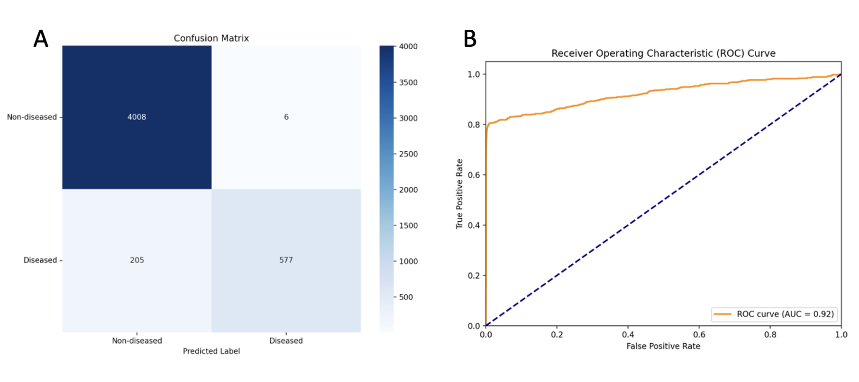
Figure 1. Performance of Traditional Neural Network Model Employing Non-Sequential Analysis. A. Confusion matrix. Confusion Matrix visualizes the performance of the classification model. The matrix compares the actual vs. predicted labels, showcasing the number of True Positives (top left), True Negatives (bottom right), False Positives (top right), and False Negatives (bottom left). B. ROC graph represents the diagnostic ability of the binary classifier. The curve plots the True Positive Rate (TPR) against the False Positive Rate (FPR) at various threshold settings.

The neural network model above had a positive predictive value (PPV) of 0.99, a negative predictive value (NPV) of 0.95, a sensitivity of 0.73, and a specificity of 0.95. Area under curve was 0.92.

3.1.2 Sequential Analysis

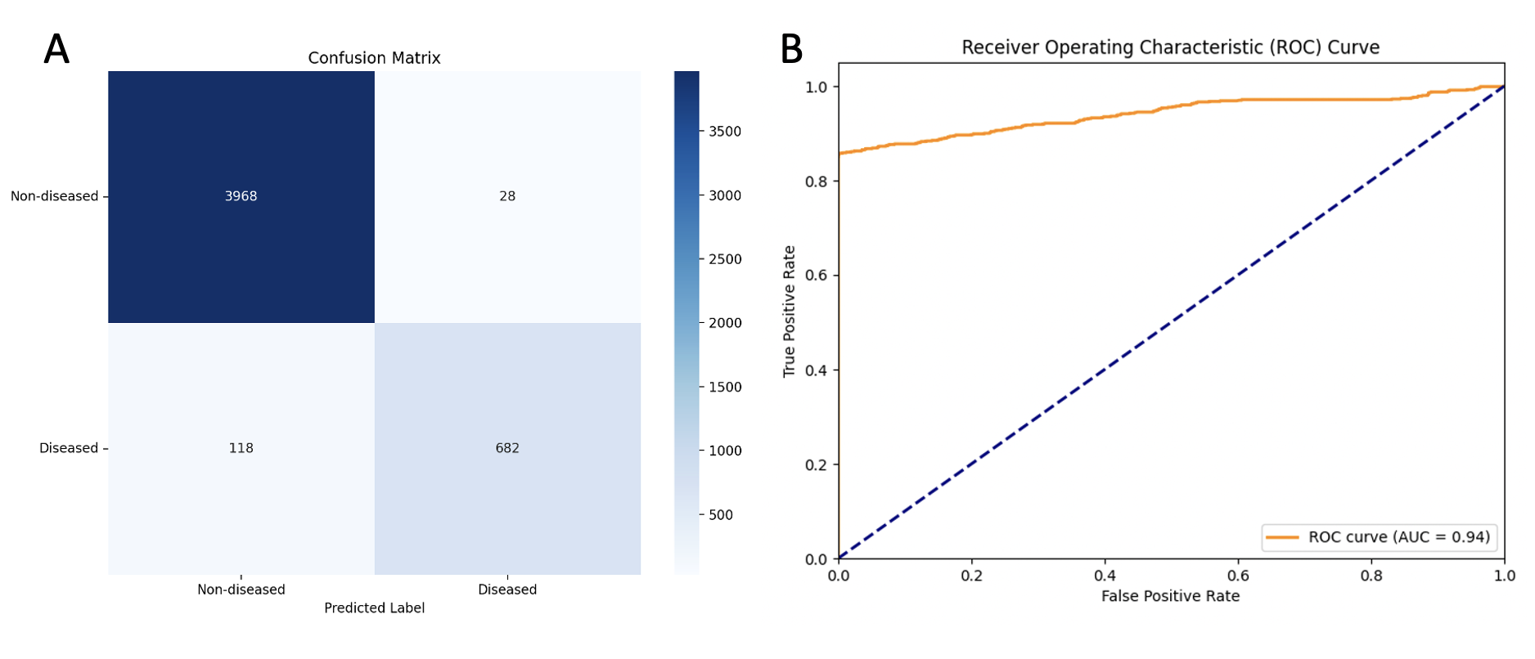

Figure 2. Performance of Traditional Neural Network Model Employing Sequential Analysis. A. Confusion matrix. Confusion Matrix visualizes the performance of the classification model. The matrix compares the actual vs. predicted labels, showcasing the number of True Positives (top left), True Negatives (bottom right), False Positives (top right), and False Negatives (bottom left). B. ROC graph represents the diagnostic ability of the binary classifier. The curve plots the True Positive Rate (TPR) against the False Positive Rate (FPR) at various threshold settings.

The neural network model above has a positive predictive value (PPV) of 0.96, a negative predictive value (NPV) of 0.97, a sensitivity of 0.85, and a specificity of 0.97.

3.1.3. Individual Time Points Analysis

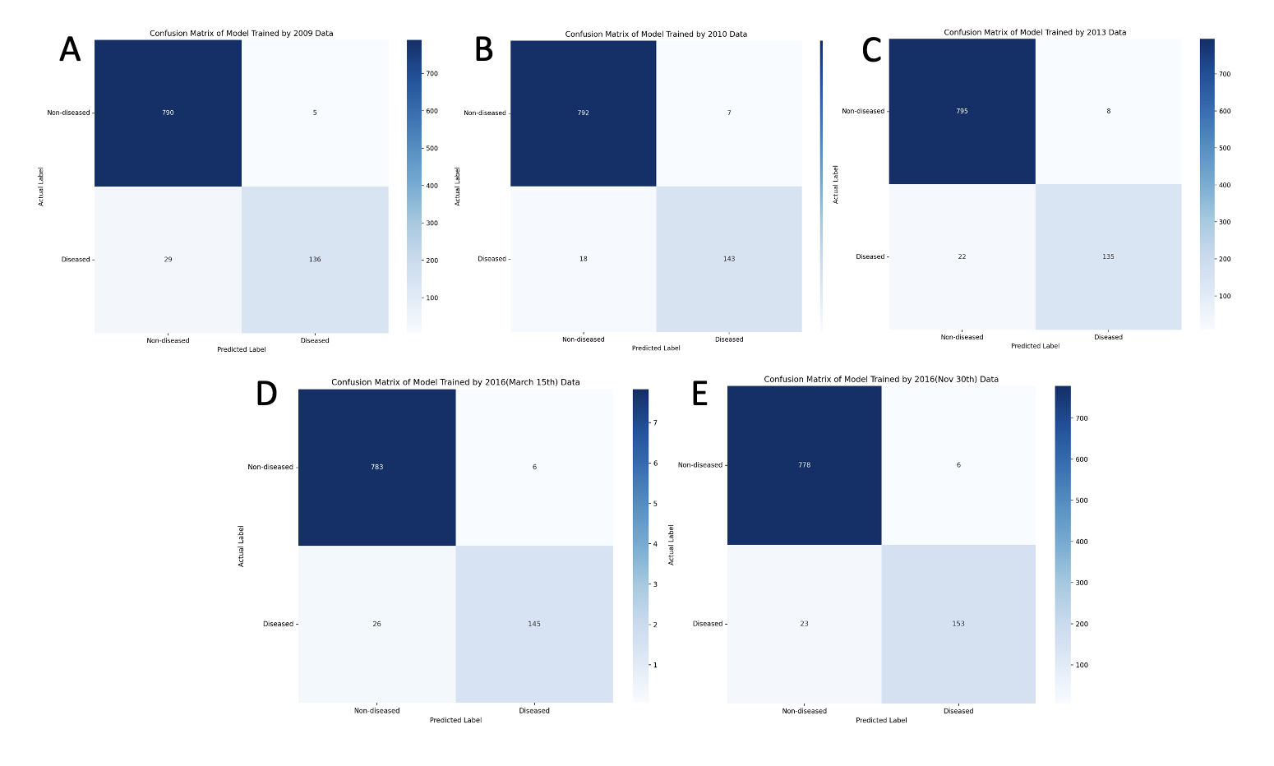

Figure 3. Confusion Matrices for Individual Neural Network Models. This graph demonstrates the effect of learning through epochs. A. Confusion matrix of the neural network model performance on the Data of 2009. A. Confusion matrix of the neural network model performance on the 2009 Data. B. Confusion matrix of the neural network model performance on the 2010 Data. C. Confusion matrix of the neural network model performance on the 2013 Data. D. Confusion matrix of the neural network model performance on the 2016(March 15th) Data. E. Confusion matrix of the neural network model performance on the 2016(November 30th) Data.

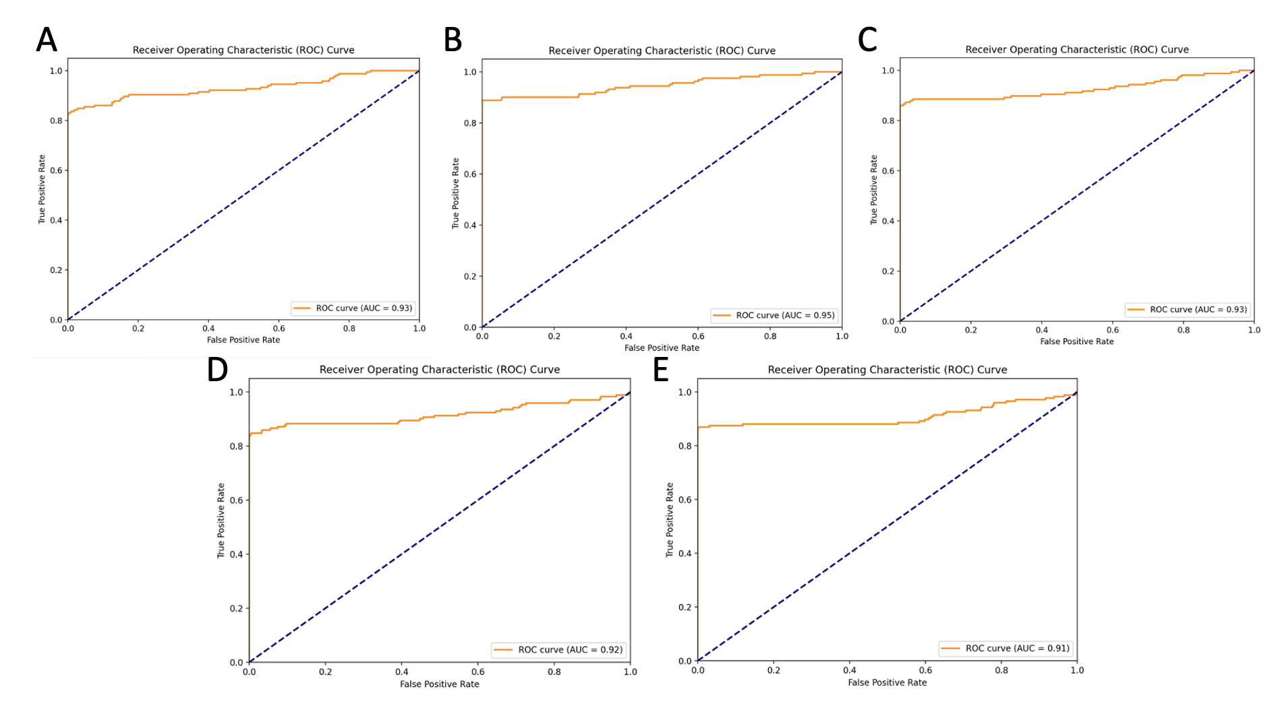
Figure 4. ROC Curves for Individual Neural Network Models. This figure presents a series of five Receiver Operating Characteristic (ROC) curves labeled from A to E(5 time points). Each panel displays the trade-off between the True Positive Rate (TPR) and False Positive Rate (FPR) for a binary classifier at various threshold settings. The ROC curves are plotted with the TPR on the y-axis against the FPR on the x-axis. The diagonal dashed line represents the line of no-discrimination, indicating a classifier with no better accuracy than random chance. The area under each ROC curve (AUC) is provided.

Table 1. Performance of Individual Deep Learning Model Trained on Data at Each Time Point. This Table shows the performance of the individual models for data at each time point, using metrics including PPV, NPV, accuracy, sensitivity and specificity.
Time Point | Accuracy(PPV) | Accuracy(NPV) | Accuracy | Sensitivity | Specificity
May 8th 2009 | 0.96 | 0.97 | 0.97 | 0.83 | 0.96
February 26th 2010 | 0.98 | 0.98 | 0.98 | 0.89 | 0.98
December 11th 2013 | 0.94 | 0.97 | 0.96 | 0.86 | 0.97
March 15th 2016 | 0.93 | 0.97 | 0.95 | 0.85 | 0.97
November 30th 2016 | 0.96 | 0.97 | 0.97 | 0.86 | 0.97

All 5 models had accuracies of above 0.95.(Figure 3; Table 1) Area under curve is over 0.9 for all 5 individual neural network models. (Figure 4.) The models developed in this study exhibited a consistent pattern of lower sensitivity of around 80% coupled with higher specificity, this is especially observed in the individual time analysis (Table 1).

3.2 Robust Analysis Using Common Machine Learning Model
Table 2. Performance of Mainstream Machine Learning Model. Here, we used the data for 2009. Accuracy indicates the percentage of correct predictions made by the model.
Model | Accuracy | Sensitivity | Specificity
Random Forest | 0.97 | 0.82 | 0.96
XGBoost | 0.97 | 0.82 | 0.96
K-Nearest Neighbors(k = 300) | 0.92 | 0.75 | 0.95
Support Vector Machine | 0.95 | 0.73 | 0.95

Accuracies of traditional machine learning models were all above 0.91, with a sensitivity ranking from 0.74-0.82.

3.3 SHAP Analysis

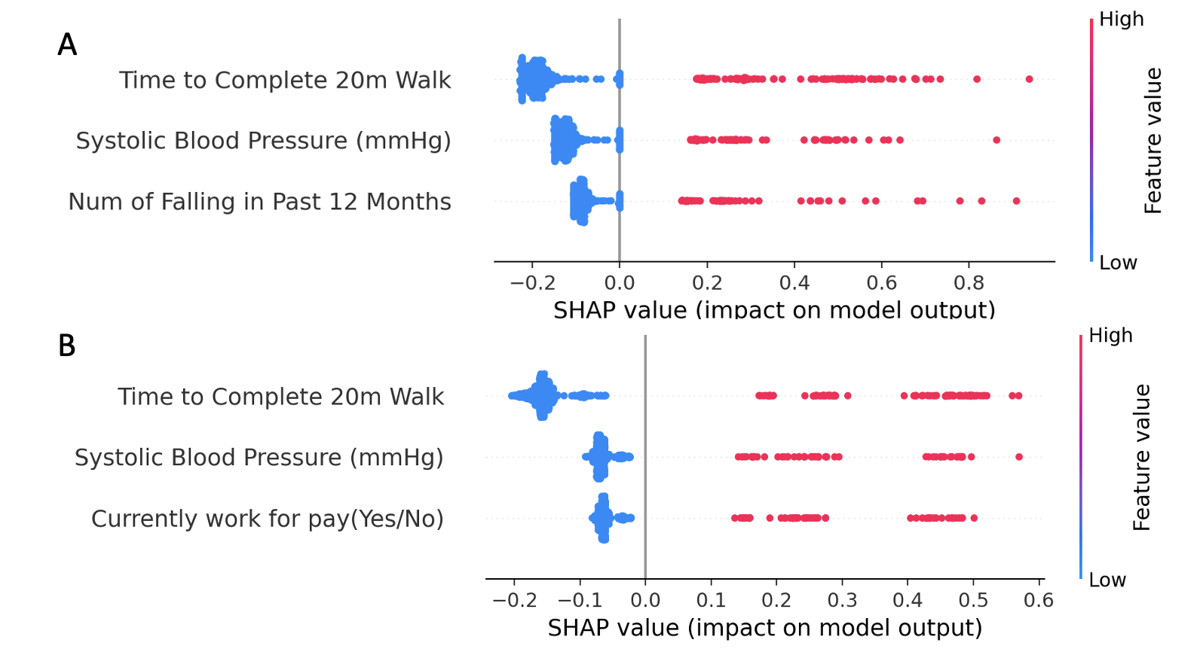

Figure 5. SHAP value graphs for the Top 3 Variables of DL and ML Models. A. SHAP value graph for the Top 3 Important Variables in the Neural Network Model Trained by the Data of November 2016. B. SHAP value graph for the Top 3 Important Variables in the Random Forest Model Trained by the Data of 2009.

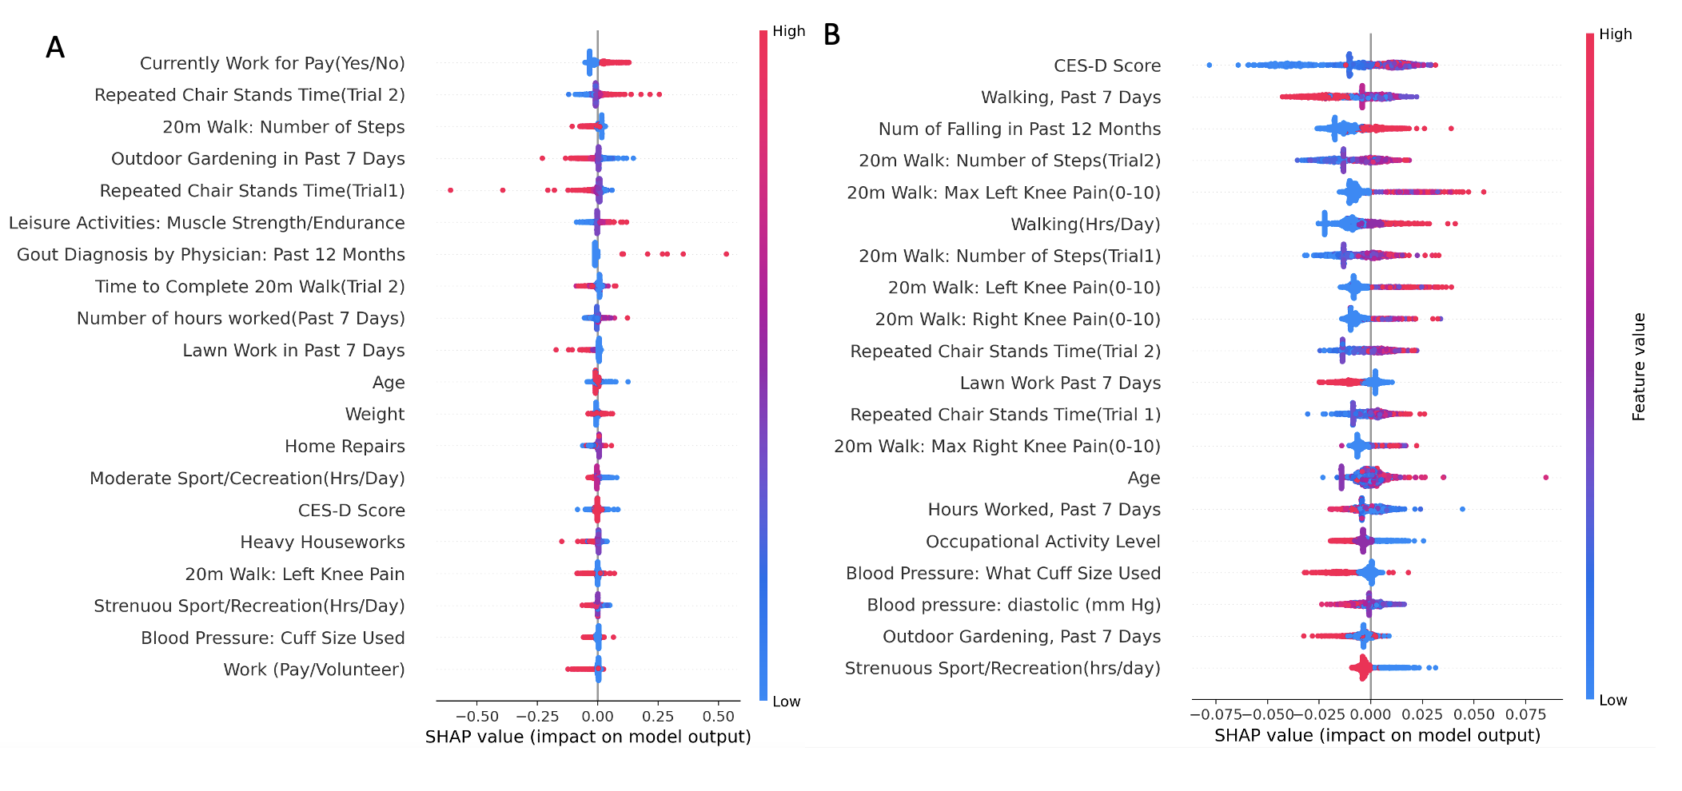
Figure 6. SHAP value graph for other Important Variables in DL and ML models. 11 variables exist in both graph. A. SHAP Value Graph for the Other Important Variables in the Neural Network Model Trained by the Data of November 2016. B. SHAP Value Graph for the Other Important Variables in the Random Forest Model Trained by the Data of 2009.

The color of the points indicates the SHAP value of the feature, with blue representing lower or less and pink representing higher or more. For example, a higher value of "Time to complete 20m walk" (pink points) tends to increase the model's chance of making arthritis prediction, while a lower value (blue points) tends to decrease it. Metrics from 20m walk examinations, systolic blood pressure and intensities of activities were shown to have particular importance in model decisions. (Figure. 5, Figure. 6)

Discussion
In this study, we evaluated the feasibility of using deep learning models to identify arthritis patients from the OAI database and compare their effectiveness with classic ML models such as Random Forest, XGBoost, K-Nearest Neighbors, and Support Vector Machine. The neural network model employed in this study represented deep learning models widely recognized for their efficacy in pattern recognition and predictive analysis [18]. Neural networks consist of layers of interconnected nodes or neurons, where each connection represents a weight that is adjusted during the learning process [24]. In binary classification tasks, such as predicting the onset of arthritis from clinical data, neural networks learn to map input features to a binary outcome through a series of non-linear transformations.
During the training of neural networks, we approached the data in non-sequential (Figure 1), sequential ways (Figure 2), and by separating models for each individual timepoints (Figure 3). The non-sequential analysis was performed after randomly assorting data from different years, this is an approach that discards longitudinal patterns, allowing the model to predict only based on individual time points. On the other hand, sequential analysis used the first four time points for training and the last for testing. The model treated data from different time points as independent observations, aiming to capture a generalized pattern of arthritis onset from various stages of patient data. provides a logical separation, ensuring that the model is tested on unseen data from a different time point, which could be indicative of its generalizability. Lastly, we also generated neural network models by using data from each individual time points. Even though the sample size is much smaller than the other two methods, this prevents repetitive information from the same patient.
Random Forest, XGBoost (XGB), Support Vector Machine (SVM), and K-Nearest Neighbors (KNN) were exploited. Random Forest is an ensemble learning method known for its robustness and effectiveness in handling both regression and classification tasks [15, 16]. XGBoost, standing for Extreme Gradient Boosting, is an optimized gradient boosting library that excels in speed and performance [19]. SVM is a versatile algorithm capable of performing linear and non-linear classification, outlier detection, renowned for its effectiveness in high-dimensional spaces.[20] KNN, simple yet effective, is a non-parametric algorithm that classifies data based on the majority class of its nearest neighbors, making it intuitive and useful for classification and regression problems in various settings [21].
To our surprise, ML models and deep learning models preformed equally well. The accuracies of over 95% indicated the huge potential for machine learning model models to diagnose arthritis using electronic health data. Suggestions of arthritis risks in real-world clinical settings without using imaging results can potentially save costs for patients who did not have the disease, offer potential risk indicators for the development of arthritis, and redistribute resources for health care providers.
Besides, the ROC curves with AUC values between 0.9 and 0.95(Figure 4) showed that the individual model had an around 90% chance to detect discriminate between a randomly chosen diseased participant and a randomly chosen healthy participant (Figure 1B, 2B & 4). Furthermore, the PPV was lower than the NPV in almost all models, indicating a potential bias during the training phase, even though all the training data was well balanced using oversampling or under-sampling (Figure 1A & 2A) (Table 1 & 2). A lower Positive Predictive Value (PPV) compared to Negative Predictive Value (NPV) signifies a greater accuracy in identifying negative instances over positive ones. This discrepancy often arises due to a higher incidence of false positives, where the test or model incorrectly labels negative cases as positive. This can be particularly pronounced in situations where the condition's prevalence is low, leading to a situation where, despite high sensitivity and specificity, the PPV remains low due to the scarcity of true positive cases.
The models developed in this study exhibited a consistent pattern of lower sensitivity of around 80% coupled with higher specificity, this is especially observed in the individual time analysis (table 1). This trend suggests that while the models are highly effective in correctly identifying healthy patients, they are somewhat less adept at detecting diseased patients. Such a disparity could be attributed to various factors inherent in the dataset and the model architecture. It is possible that the dataset contains more distinct and consistent features for non-arthritic cases, leading to higher specificity. In contrast, the heterogeneity in manifestations of arthritis might not be fully captured, affecting sensitivity. Additionally, the imbalance in the dataset, with a possible underrepresentation of arthritic cases, could have biased the model towards the majority class, further contributing to this discrepancy.
Notably, the K-nearest Neighbors model shows a relatively low accuracy and sensitivity score compared with other machine learning model(Table. 2). This may be due to overfitting caused by the oversampling of the dataset in the high-dimensional space. KNN models, as mentioned in method section, plot the test data with the training data, and study the neighboring data points to make classifications, which resembles how SMOTE oversamples the data. Therefore, the oversampling strategy performed by SMOTE might overwhelm the KNN model.
The SHAP value graphs from both the random forest and our specialized deep learning model (Figures 5 & 6) demonstrated the interpretability of our models by revealing similar influential variables that steer the predictions, despite the models being trained on distinct datasets and utilizing different learning algorithms. These graphs serve not only to validate the models' interpretability but also to confirm the consistency of variable importance across diverse analytical methods. For instance, systolic blood pressure, known to have a positive correlation with osteoarthritis onset, maintains a positive impact on the disease onset predictions made by both models (Figure 5 A&B) [25]. In contrast, diastolic blood pressure is inversely related to the model’s predictions (Figure 6 B). There were other significant variables, such as those related to the 20-meter walk performance, the frequency of muscle-strengthening leisure activities, and the intensity of household chores, whose relevance to the models' decisions is both consistent and logical. (Figure 6)

Our study does have several limitations. First, our results were not validated with an external EHR data set. Although OAI is a large, real-world clinical database, the study population may not be representative of the general arthritis population. In fact, a higher proportion of participants in this study have a risk for osteoarthritis than other types of arthritis, which can make the model predicting powers biased to osteoarthritis. Second, this study is a secondary analysis of observational EHR data, we relied on the data quality of the database. Missing data are present and documentation errors could occur, many variables are the subjective responses from patients and bias could occur through the timepoints. Data imputation process might neglect that and therefore imputing noisy data that influence the model performance. Thirdly, we relied on patient reports on whether they are diagnosed with arthritis. Some of the data points that are treated as non-diseased could have been diseased but not diagnosed. Fourthly, the PPV was overall lower than the NPV(Table 1). The reason of the problem should be the scarcity of the data for diseased participants, leading to bias in oversampling algorithm. Other studies in previous studies reduce this confounding variable by implementing assessing methods based on imaging results to robustly categorize patients’ disease states. Lastly, the training and testing data include results from the same patients at different time points. Despite that we dropped the column for patient’s ID, sequential and non-sequential deep learning model might “identify” patient through feature characteristics. This might result in biased accuracy for the model. Nevertheless, EHR-based study shows promise and potential in real world settings.

Conclusions
Arthritis is often underdiagnosed; many people do not take caring actions before symptoms get unmanageable. This study systematically explored the feasibility of using different AI algorithms including DL and ML models. Our study identified no significant difference in accuracy among different predicting models, but we compared the important features that each model used, which could be used to help reveal future research directions. The current models present the potential to identify patients with arthritis, it can be used as a screening technique to select susceptible patients for confirmatory studies. Future work shall focus on increasing model accuracy by increasing data size for both training and testing groups, and include some EHR from the general public to reduce model bias. Other data sets should be used to validate the prediction models and a more knowledge-driven approach for variable filtering should be applied to increase the interpretability of the model.

List of Abbreviations Used (If Any)
AI: Artificial Intelligence
AUC: Area under curve
CES-D Score: Center for Epidemiologic Studies Depression Scale Score
DL: Deep Learning
EHR: Electronic Health Record
FN: False negative
FP: False positive
KNN: K-Nearest Neighbors
ML: Machine Learning
MRI: Magnetic Resonance Imaging
NPV: Negative Predictive Value
OAI: Osteoarthritis Initiative
PPV: Positive Predictive Value
ROC: Receiver operating characteristic
SHAP: SHapley Additive exPlanations
SMOTE: Synthetic Minority Over-sampling Technique
SVM: Support Vector Machine
TN: True negative
TP: True positive
XGB: XGBoost

Conflicts of Interest
The authors declare that they have no conflict of interests in publication

Ethics Approval and/or Participant Consent
The use of the OAI data is approved by the National Institute of Mental Health Data Archive.

Authors' Contributions
XK: Made contributions to the design of the study, collected data, created the machine learning models, and drafted the method, result, and discussion section of the manuscript.
JC: Contributed to study design, assisted with the collection of data, conducted manual variable filtering, and drafted the abstract, introduction, and discussion section of the manuscript.

Acknowledgements

This project was supported by the Osteoarthritis Initiative (OAI), a public-private partnership comprised of five contracts (National Institute of Arthritis and Musculoskeletal and Skin Diseases contracts N01-AR-2-2258, N01-AR-2-2259, N01-AR-2-2260, N01-AR-2-2261, and N01-AR-2-2262) funded by the National Institutes of Health (NIH), with research conducted by the OAI Study Investigators. Private funding partners include Merck Research Laboratories; Novartis Pharmaceuticals Corporation, GlaxoSmithKline; and Pfizer, Inc. Private sector funding for the OAI is managed by the Foundation for the National Institutes of Health. This study was also supported by Randa Mudathir, a mentor from the Undergraduate Research in Natural and Clinical Science and Technology (URNCST) Journal, we thank her for her advice and feedback during our planning, and writing of this manuscript.

Funding
This study was not funded.

References
[1]. Senthelal S, Li J, Ardeshirzadeh S, Thomas MA. Arthritis. In: StatPearls [Internet]. Treasure Island (FL): StatPearls Publishing; 2023 [cited 2023 Nov 26]. Available from: http://www.ncbi.nlm.nih.gov/books/NBK518992/
[2]. Canada PHA of. Chapter 1: Life with arthritis in Canada: a personal and public health challenge – What is arthritis and how common is it? [Internet]. 2010 [cited 2023 Nov 26]. Available from: https://www.canada.ca/en/public-health/services/chronic-diseases/arthritis/life-arthritis-canada-a-personal-public-health-challenge/chapter-one-what-is-arthritis-and-how-common-is-it.html
[3] The Truth About Arthritis - Prevalence & Impact [Internet]. [cited 2023 Nov 26]. Available from: https://arthritis.ca/about-arthritis/what-is-arthritis/the-truth-about-arthritis
[4] Arthritis Related Statistics | CDC [Internet]. 2023 [cited 2023 Nov 26]. Available from: https://www.cdc.gov/arthritis/data_statistics/arthritis-related-stats.htm
[5] Weinstein AM, Rome BN, Reichmann WM, Collins JE, Burbine SA, Thornhill TS, et al. Estimating the Burden of Total Knee Replacement in the United States. J Bone Joint Surg Am. 2013 Mar 6;95(5):385–92.
[6] Turkiewicz A, Gerhardsson de Verdier M, Engström G, Nilsson PM, Mellström C, Lohmander LS, et al. Prevalence of knee pain and knee OA in southern Sweden and the proportion that seeks medical care. Rheumatology. 2015 May 1;54(5):827–35.
[7] Bortoluzzi A, Furini F, Scirè CA. Osteoarthritis and its management - Epidemiology, nutritional aspects and environmental factors. Autoimmunity Reviews. 2018 Nov 1;17(11):1097–104.
[8] Michaud K. The National Data Bank for Rheumatic Diseases (NDB). Clin Exp Rheumatol. 2016;34(5 Suppl 101):S100–1.
[9] Tool for Osteoarthritis Risk Prediction (TOARP) over 8 years using Baseline Clinical Data, X-ray, and MR imaging - Data from the Osteoarthritis Initiative
[10] A standard database for rheumatic diseases. Arthritis & Rheumatism. 1974;17(3):327–36.
[11] Artificial Intelligence in Rheumatoid Arthritis: Current Status and Future Perspectives: A State-of-the-Art Review
[12] Arthritis Risk Factors | CDC [Internet]. 2023 [cited 2023 Nov 26]. Available from: https://www.cdc.gov/arthritis/basics/risk-factors.htm
[13] Norgeot B, Glicksberg BS, Trupin L, Lituiev D, Gianfrancesco M, Oskotsky B, et al. Assessment of a Deep Learning Model Based on Electronic Health Record Data to Forecast Clinical Outcomes in Patients With Rheumatoid Arthritis. JAMA Network Open. 2019 Mar;2(3):e190606.
[14] Shickel B, Tighe PJ, Bihorac A, Rashidi P. Deep EHR: A Survey of Recent Advances in Deep Learning Techniques for Electronic Health Record (EHR) Analysis. IEEE Journal of Biomedical and Health Informatics. 2018 Sep;22(5):1589–604.
[15] Breiman L. Random forests. Machine Learning. 2001;45(1):5-32. doi:10.1023/A:1010933404324​
[16] Rigatti SJ. Random forest. Journal of Insurance Medicine. 2017 Jan 1;47(1):31-9.
[17] Chawla NV, Bowyer KW, Hall LO, Kegelmeyer WP. SMOTE: Synthetic Minority Over-sampling Technique. arXiv:1106.1813. 2002
[18] Deep Learning: A Comprehensive Overview on Techniques, Taxonomy, Applications and Research Directions. SN Computer Science. 2021 Aug 18;2(5):420​
[19] Chen T, Guestrin C. Xgboost: A scalable tree boosting system. InProceedings of the 22nd acm sigkdd international conference on knowledge discovery and data mining 2016 Aug 13 (pp. 785-794).
[20] Noble WS. What is a support vector machine?. Nature biotechnology. 2006 Dec 1;24(12):1565-7.
[21] Peterson LE. K-nearest neighbor. Scholarpedia. 2009 Feb 21;4(2):1883.
[22] Bradley AP. The use of the area under the ROC curve in the evaluation of machine learning algorithms. Pattern recognition. 1997 Jul 1;30(7):1145-59.
[23] Van den Broeck G, Lykov A, Schleich M, Suciu D. On the tractability of SHAP explanations. Journal of Artificial Intelligence Research. 2022 Jun 23;74:851-86.
[24] LeCun Y, Bengio Y, Hinton G. Deep learning. nature. 2015 May 28;521(7553):436-44.
[25] Association between hypertension and risk of knee osteoarthritis: A meta-analysis of observational studies. Medicine

All article types: All references, including URLs, must be numbered consecutively, in square brackets, in the order in which they are cited in the text, followed by any in tables or legends. Each reference must have an individual reference number. If automatic numbering systems are used, the reference numbers must be finalized and the bibliography must be fully formatted before submission. Note: In accordance with CrossRef, for cited journal articles please ensure that you report the hyperlink as a DOI weblink and NOT a weblink from the journal’s webpage (i.e. https://doi.org/10.26685/urncst.11 and NOT https://urncst.com/index.php/urncst/article/view/11). To speed up your referencing process, use the CrossRef free DOI lookup: https://www.crossref.org/guestquery/.
The URNCST Journal follows the reference style outlined by the International Committee of Medical Journal Editors (ICMJE) also known as the Vancouver citation style. Some cited examples are provided below:
Standard journal articles
Lopatto D. Survey of undergraduate research experiences (SURE): First findings. Cell Biology Education. 2004 Dec 21;3(4):270-7. https://doi.org/10.1187/cbe.04-07-0045

Kardash CM. Evaluation of undergraduate research experience: Perceptions of undergraduate interns and their faculty mentors. Journal of Educational Psychology. 2000 Mar;92(1):191. https://doi.org/10.1037/0022-0663.92.1.191

Complete book, authored
Laursen S, Hunter AB, Seymour E, Thiry H, Melton G. Undergraduate research in the sciences: Engaging students in real science. John Wiley & Sons; 2010 Jun 15.

Website
The Council on Undergraduate Research [Internet]. Undergraduate Journals. [cited 2017 Jun 29]. Available from: http://www.cur.org/resources/students/undergraduate_journals/

For more examples of Vancouver citation style, please see: https://www.bma.org.uk/library/library-guide/reference-styles

Notes on Figures, Tables and Additional Files

Note to Authors: Please delete this instruction page prior to submitting your manuscript.

Figures
All article types: Figures should be provided where they should be displayed in the word document text file. Each figure should be able to fit on a single page in portrait format, and they should be numbered in the order in which they appear cited in the manuscript (i.e. Figure 1, Figure 2, etc.). Each figure must be accompanied with a caption directly below it. Please note that the URNCST Journal only publishes articles in online formats, and therefore, there are no additional charges for the use of color figures. Important: It is the responsibility of the author(s) to obtain permission from the copyright holder to reproduce figures that have previously been published elsewhere, which should be scanned and emailed to the editorial office in case of acceptance together with your Publication Agreement Form.

Tables
All article types: Tables should also be provided where they should be displayed in the word document text file. Each table should be able to fit on a single page in portrait format, and they should be numbered in the order in which they appear cited in the manuscript (i.e. Table 1, Table 2, etc.). Each figure must be accompanied with a caption directly above it. All tables should be formatted using the “Table object” (i.e. Insert > Table) in a Microsoft Word to ensure that columns of data are kept aligned when the file is sent electronically for review. Important: It is the responsibility of the author(s) to obtain permission from the copyright holder to reproduce figures or tables that have previously been published elsewhere, which should be scanned and emailed to the editorial office in case of acceptance together with your Publication Agreement Form.

Additional Files
All article types: For figures and tables that are too large to be included with the manuscript file, please upload them as multimedia appendices. Other additional file types that you wish to accompany your manuscript may include research instruments (questionnaires), movie files, original/raw data (SAS/SPSS, Excel, Access database, etc.). Important: It is the responsibility of the author(s) to obtain permission from the copyright holder to reproduce any additional file that have previously been published elsewhere, which should be scanned and emailed to the editorial office in case of acceptance together with your Publication Agreement Form.

